

LAB EXPERIMENT RECORD

SET 14
Department | Artificial Intelligence and Data Science
Course Code / Course Name | DSA0601 / Data Handling and Visualization
Name / Register Number | K.L Dinesh Eshwar / 192425027
Date / Day | 08/10/2026

Aim
To analyze survey results analysis using the requested visualizations and dashboard views.

Dataset
Survey Results Analysis
Respondent | Question_1 | Question_2 | Question_3
1 | A | B | C
2 | B | A | D
3 | C | A | B

R Data Setup
Run this setup once before the R programs below. The dataset is defined inline so each record can be copied and run without a separate CSV file.
R data setup
dat <- data.frame(
Respondent = c(1, 2, 3),
Question_1 = c("A", "B", "C"),
Question_2 = c("B", "A", "A"),
Question_3 = c("C", "D", "B")
)

PROGRAM 1: Question 1 Stacked Responses
Create a stacked bar chart displaying the answer distribution for Question 1.
R code
counts <- table(factor(dat$Question_1, levels=c("A","B","C","D")))
barplot(matrix(counts,nrow=1), col=rainbow(4), legend=TRUE, xlab="Question", ylab="Respondents", main="Question 1 Response Distribution")

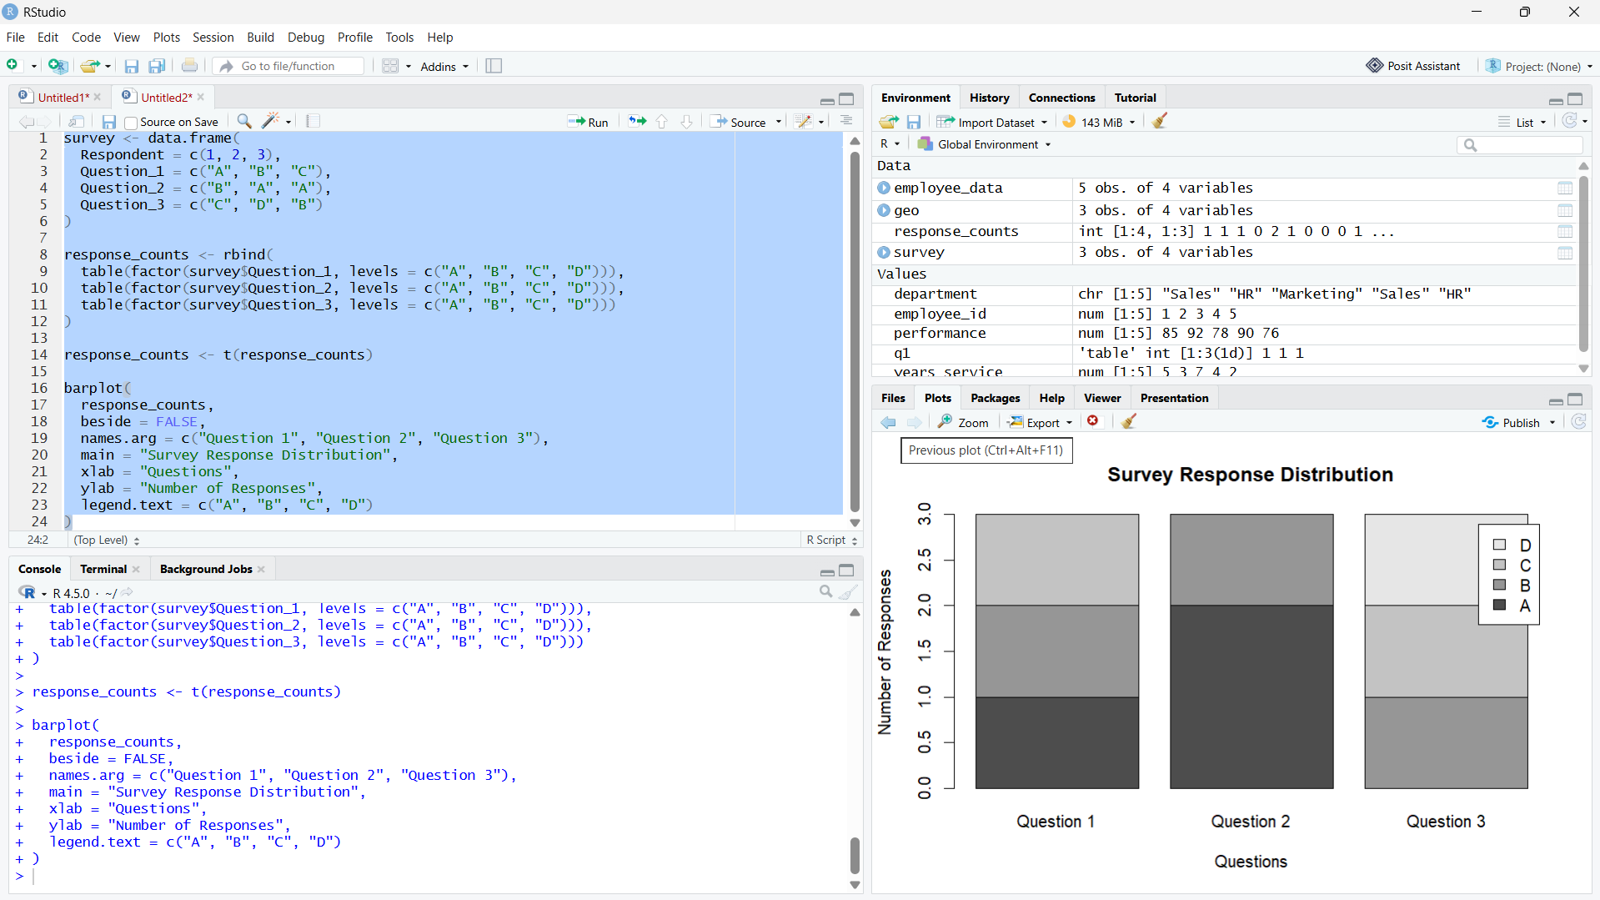

Output 1: Question 1 Stacked Responses

Observation: Question 1 has one response each for A, B, and C.

PROGRAM 2: Radar Chart of Response Patterns
Create a radar chart showing the overall response pattern across all three questions.
R code
library(fmsb)
counts <- rbind(c(1,1,0), c(1,1,1), c(1,0,1), c(0,1,0))
colnames(counts) <- c("Question 1","Question 2","Question 3")
radarchart(rbind(max=c(2,2,2), min=c(0,0,0), counts), axistype=1, title="Response Pattern by Answer")

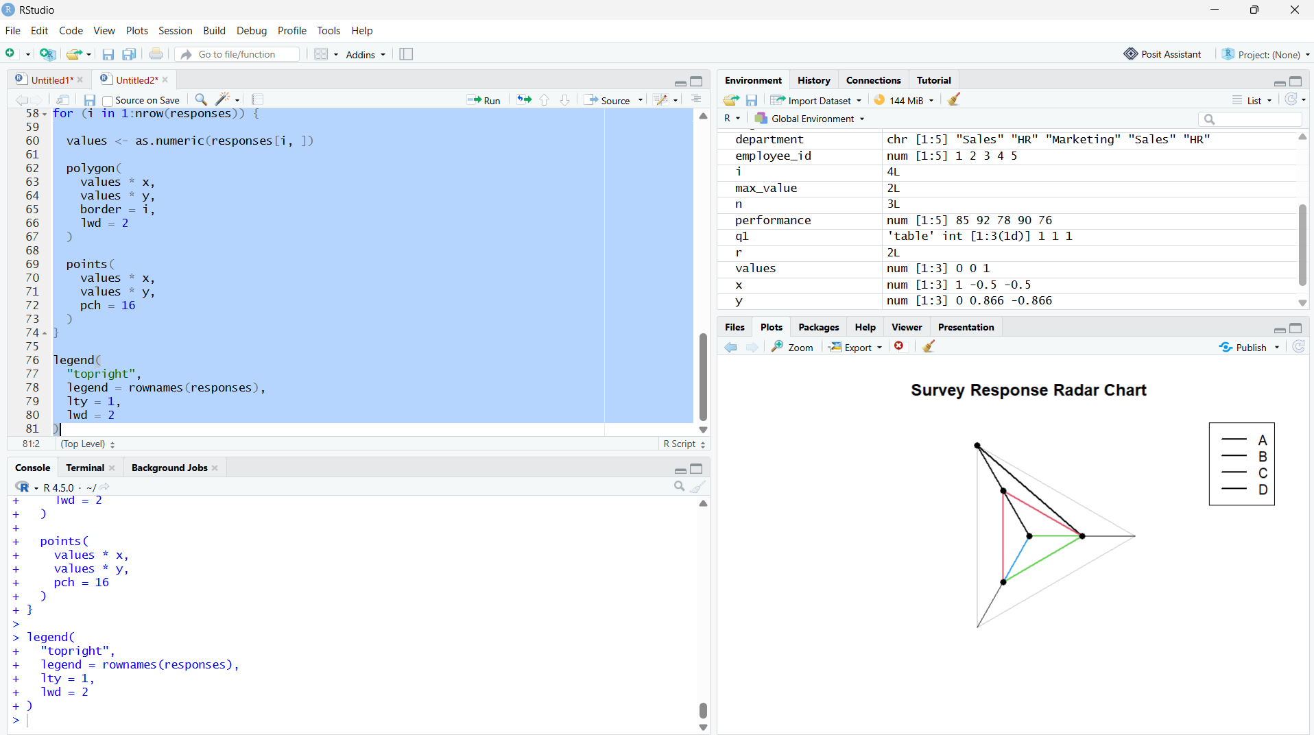
Output 2: Radar Chart of Response Patterns
Observation: Answer B appears once in each question; Answer D appears only in Question 3.

PROGRAM 3: Survey Results Table
Display each respondent's answers in a labeled table.
R code
print(dat)

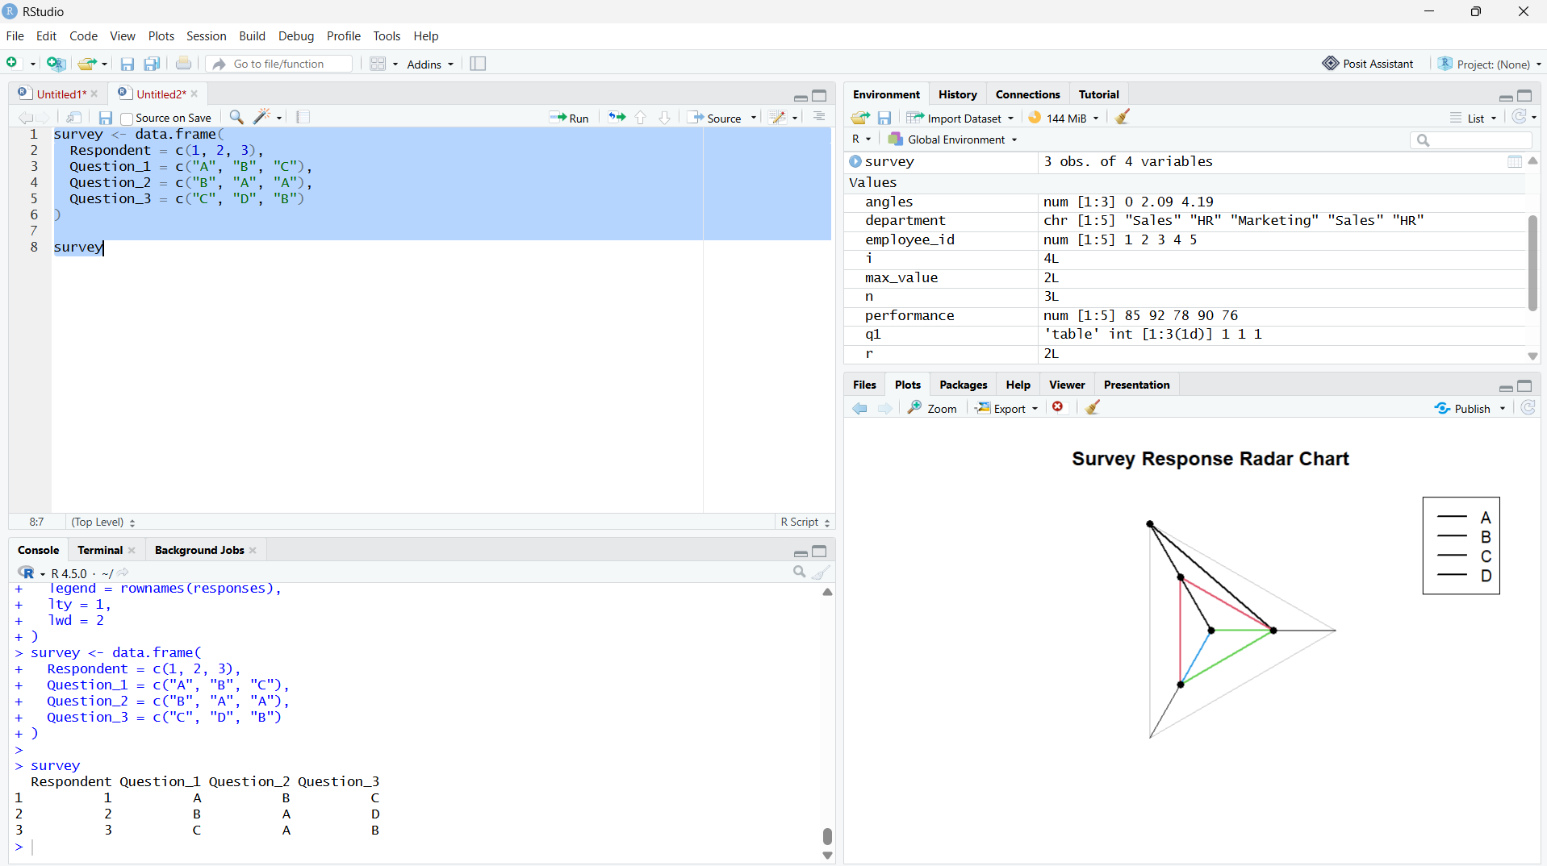

Output 3: Survey Results Table

Observation: The table contains the three respondent records and all question answers.

PROGRAM 4: Survey Results Dashboard
Build a Tableau dashboard combining the Question 1 stacked bar, response radar chart, and survey table.
Tableau build steps
Tableau dashboard build
1. Connect to the survey results table.
2. Create a stacked bar view of Question_1 response counts.
3. Pivot the three question columns to Question and Answer fields before creating the response-pattern view.
4. Add a respondent table and combine the views on a dashboard.

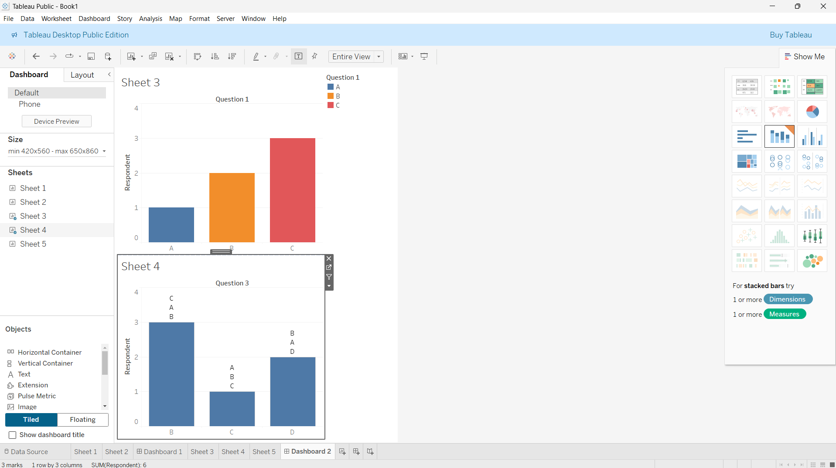
Output 4: Survey Results Dashboard
Observation: The preview combines the Question 1 distribution with the all-question response pattern and respondent details.

Procedure
1. Review the dataset table and confirm any illustrative fields noted in the record.
2. Run the R setup block once, then run the requested program code.
3. Compare the output screenshot with the observation and replace illustrative values when actual data is available.
4. For Tableau tasks, connect to the displayed data and follow the dashboard build steps.

Result
The requested charts and dashboard views for Set 14 were prepared from the displayed dataset. Outputs include labels, short observations, and code or dashboard construction steps.

Key Functions Used
plot(), barplot(), hist(), boxplot(), table().

